Ran Chen 11 (subgroup 3)

Wang Zhang 50 (subgroup 3)

**CS551 Advanced Software Engineering**

**Challenge #1 (Hackathon)**

**Shopping Helper**

1) **Design**

A. Architecture Diagram

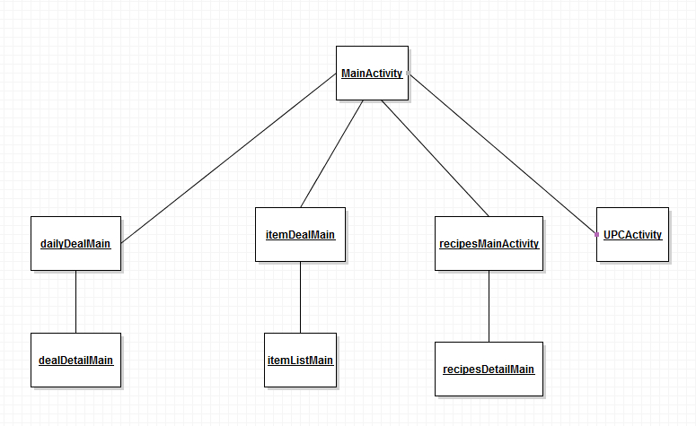

B. Class Diagram

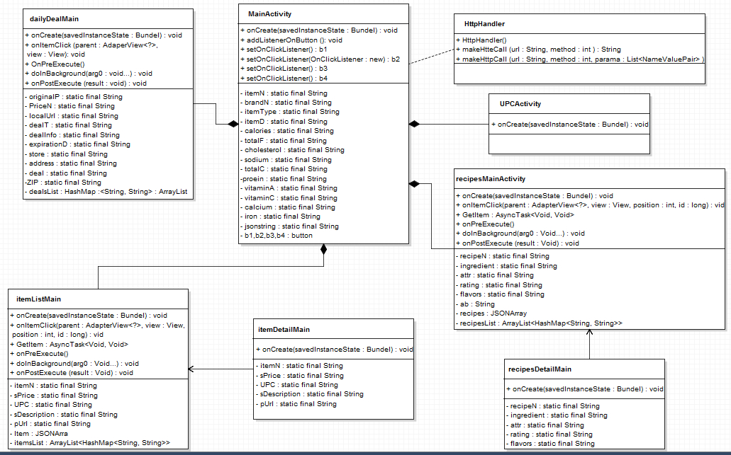

2. **Features Implemented**

A. **Web Services**

a. **Existing services/APIs** :

We basically use four APIs for our project. They are contain daily deals, item details, food nutrition and recipes.

Coupon API : http://api.8coupons.com/v1

Walmart API: [http://walmartlabs.api.mashery.com/v1/](http://walmartlabs.api.mashery.com/v1/search?query)

Recipes API: http://api.yummly.com/v1/api

Food Nutrition API: [https://api.nutritionix.com/v1_1/](https://api.nutritionix.com/v1_1/item?upc=%22+ZText)

B. **Database**

1. **Data sources: API**

All our data sources come from these four APIs, which I state above.

C. **Mobile User Interface**

Our Mobile Application is android based. The simple interface of our application, it all designed by our own. The screenshots of our application interface will show below.

3) **Include Screenshots of the Features**

The main page: This is our application main page, it contains four features. Such as item detail check, food recipes, food nutrition and daily deals.

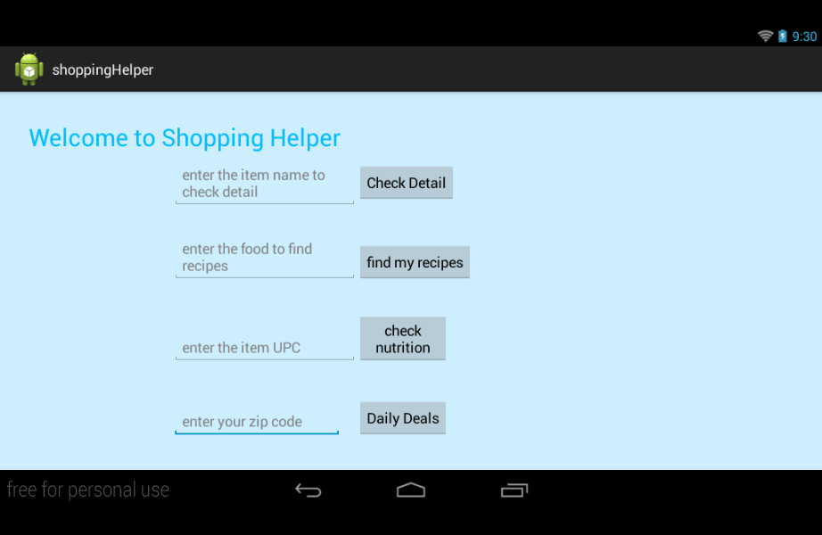

The list of daily deals: After user type in the zip code, our application will display a deal list which based on that zip area.

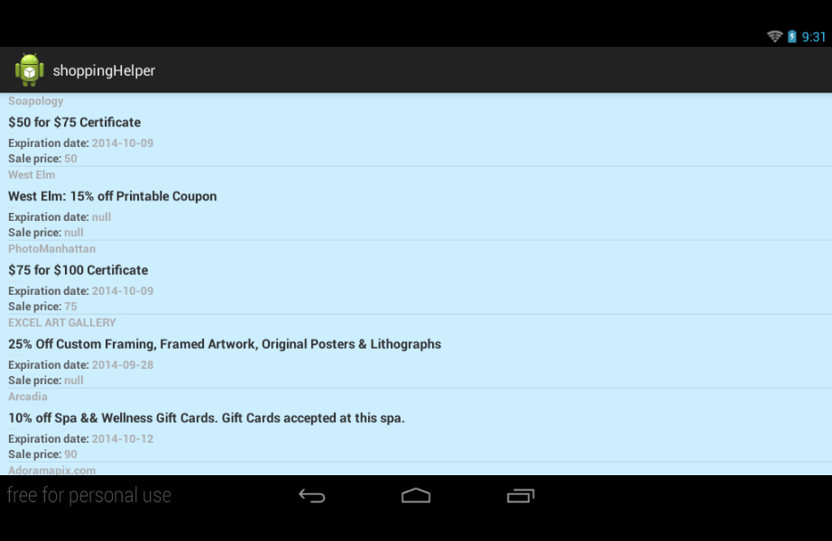

The deals item page: after user click one of deal from deal list, this page will show up. Basically it shows more detail about that deal.

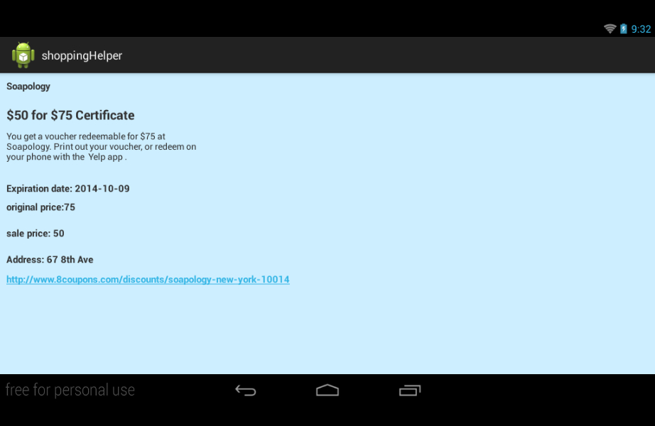

Food Nutrition Page: this page display all the Nutrition information based on the UPC which user entered in main page.

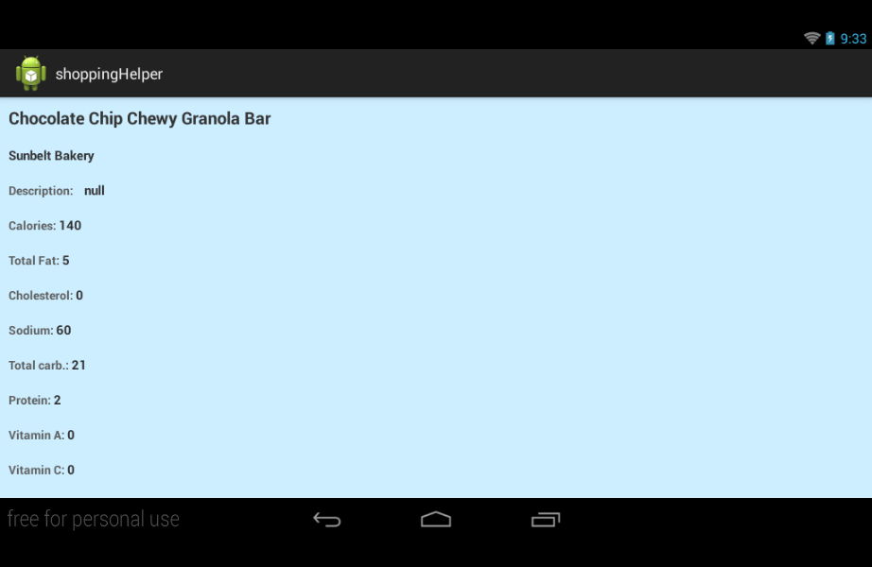

Food Recipes List Page: This page display the list of recipes based on the key word of user type in

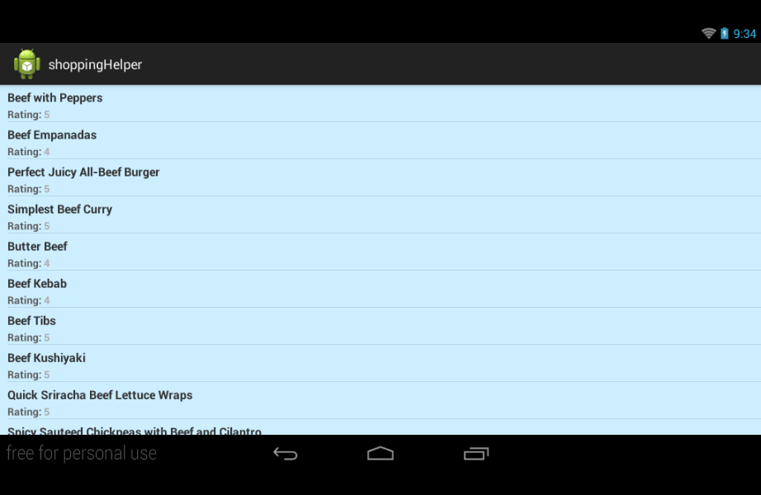

The food recipe detail page: In the page, it displays dish recipe detail. Teach user what ingredients needed for this recipe.

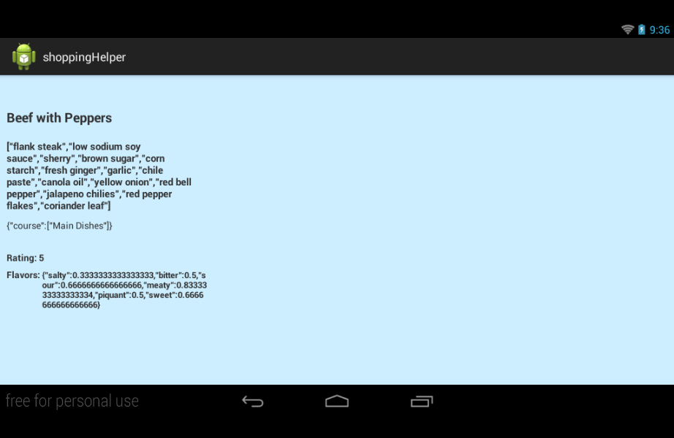

Item list page: in this page, it displays item name with price list which based on key word user type in.

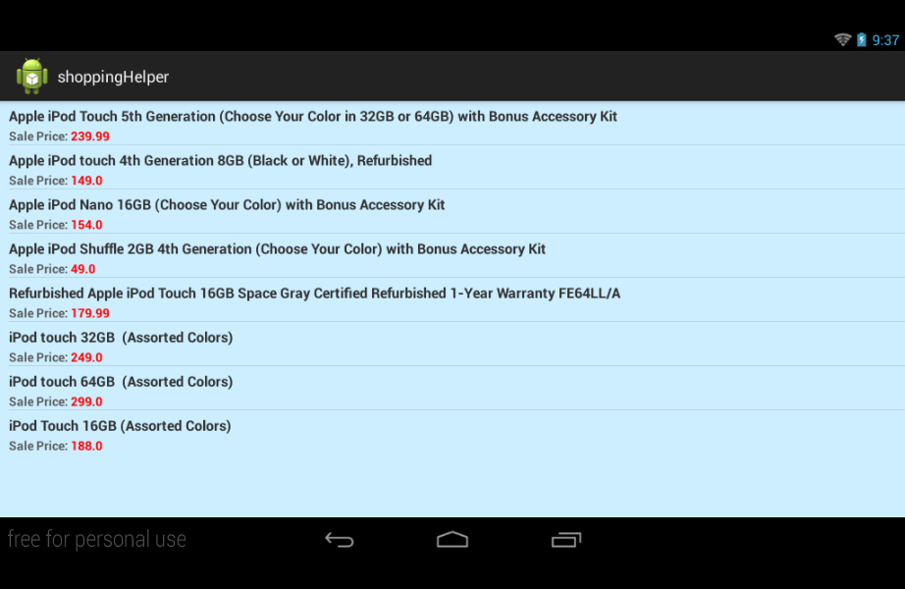

The item detail page: in the page, it display the detail of the item.

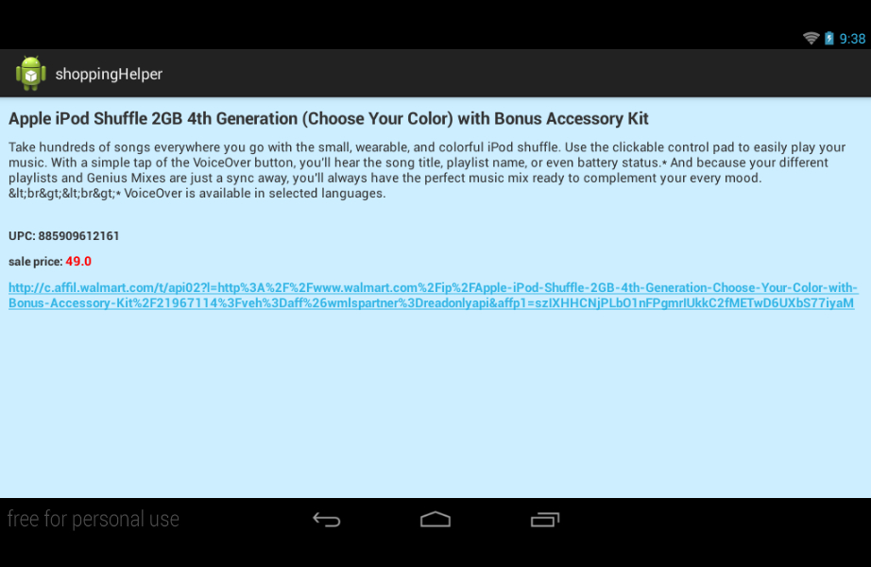

4) **Include your Challenge#1 Github URL**

<https://github.com/wzhang1011/CS551_Challenge1.git>

5) **Limitations**

Some of API has limitation on the time of get request. For the application, we do not have function to verify what user type in, which means if user type in some number or word that database cannot recognize or there is no information, our application will return nothing or blank list.

6) **References**

* Walmart Product Database

[https://developer.walmartlabs.com/](https://developer.walmartlabs.com/%20%20)

* 8 Coupons Database

<http://www.8coupons.com/api/doc>

* Yummly Recipes and Food Database

<https://developer.yummly.com/>

* Nutritionix Database

<http://www.nutritionix.com/api>